Fracturing the Glass Ceiling: History of the Women’s Caucus in the Society for Photographic Education

Rebecca Zeiss

September 20, 2020

Nathan Lyons started the Society for Photographic Education (SPE) and then held the first national conference in 1963, with twenty-one founding members, all of them men. The membership soon expanded, but admission to the group was available only to photography professionals and only by invitation. The first woman nominated for membership was Grace Mayer in 1964, Grace was followed that same year by four other women. Still, in 1977 the Society for Photographic Education was primarily a white male group of photographers. At that point, SPE was 25% women with relatively no students, who were at that time discouraged from participating in the organization. This was at a time when photography was considered a minor art, and many photographers, photography professionals, and photography academics were interested in increasing the prominence, visibility, and presence of photography in academia. The fields of photography, independent film, and video underwent considerable expansion as new journals, exhibition spaces, and education programs emerged across the country. As the percentage of women increased in academic institutions and in the SPE organization, few held prestigious full-time tenured positions.

The decade of the '70s, along with a second-wave feminism, brought an onslaught of women's actions to proclaim independence and to be treated fairly and equally. The nation was going through an awakening, and following suit, so did the Society for Photographic Education. The norms were changing, and the numbers of women joining the SPE increased greatly. These women, regardless of their stance in relation to questions of women’s liberation, were interested in raising the visibility of women’s issues and work in the SPE. These women wanted to promote a broader look at the field of photography and the concerns for women and others within it.

Plans for a women’s group were beginning as early as 1974 and began to emerge in 1977. These records can be found in the Women’s Caucus (WC) minutes from the 1980s. However, a significant event at the 1978 SPE conference, held in Monterey-Pacific Grove, CA, spurred the group to action. A presentation by Les Krims of his personal work, including images of naked women, some believed to be his students, prompted a walk out. The women who left the auditorium and were drawn together by a common cause stayed in the general open space outside of the conference rooms and shared their opinions. They found they had related issues to discuss: invisibility of artists, the lack of representation of women and people of color on the conference programs and in the organization. This spontaneous moment is considered the first manifestation of the Women's Caucus (WC).

Even though the population of women attendees at the Society’s conferences were increasing at this time, the presenters remained mostly men, and few panels addressed issues of interest to women. By 1980, women represented 40% membership of the SPE. This would be the year the WC made their official debut, when Martha Rosler placed a notice in the conference program for the first ad hoc meeting of the Women's Caucus. At 9:30 am of the first conference day, forty-five women showed up and convened the first official meeting in the Stevensville Country Club’s Starlight Room in Swan Lake, NY. Chairs were reorganized into a large circle, and introductions were made along with sharing personal and professional concerns. The circle was chosen as a symbol for breaking the linear, hierarchical, and bureaucratic organization status quo. The group found that more time was needed, and at a second meeting, the following day, thirty more women attended. Included on the list of attendees was Diane Neumaier, Sally Stein, Martha Rosler, Catherine Lord, Martha Gever, Barbara Jo Revelle, Linda Brooks, and many others. The women who filled the space are now considered to be the founders of the Women’s Caucus (WC). Although all may not have considered themselves members of a new caucus, nevertheless, they made history that day.
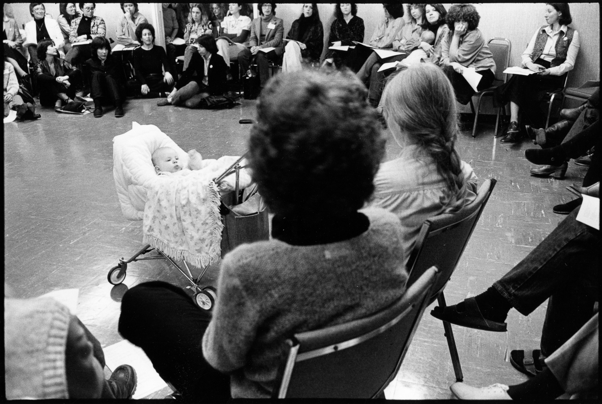
Founding the Women’s Caucus, Swan Lake, NY, 1980. (Far left, back row, Joann Seador. Back row on right, Linda Brooks and Barbara Jo Revelle to her right). Photograph by Judith Lermer Crawley.

The Women's Caucus arose with three intentions: support, presence, and shared equality. Their first meeting with Martha Rosler acting as chair discussed concerns of hiring practices, lack of diversity, equitable distribution of funds within SPE, equitable representation, cooperation with other organizations, planning workshops, publications, symposiums, and discussing issues pertaining to parenting, childcare, women's history, female imagery, humanitarian concerns, the sharing of personal ideas, and networking. It is no wonder that a second meeting was needed.

Many of the proposed projects were able to be organized within the group itself, such as support, workshops, exhibitions, and childcare help at conferences, which continued through the years. Some of the projects are still in place today. Several demands emerged from this first meeting. Most important was the request for the inclusion of women's programming at the annual conference, including a caucus track program, a four-guest-edited issue of the SPE’s quarterly magazine Exposure, channels for information exchanges within SPE, and finally, the inclusion of Women's Caucus representatives on the SPE board.

At this time there were a few women on the SPE board, making the next primary focus of the Women's Caucus to have a representative on the Board. With that, the WC could push for another objective, their participation in the broader national conference programing. The bylaws at that time stated that all members on the Board must represent all of the SPE, which could be interpreted as contradictory to special interest groups. The women gathered friends, allies, and momentum and of these demands, only a startup version of the programming proposal request would be in place by the following year.

It is interesting to note that at this very same time, there were sixteen pages of signatures collected by the women to support the SPE's continuing refusal to hold SPE meetings in states which had not ratified the Equal Rights Amendment. To this date not all states have ratified, and the amendment sits dormant. For SPE, it appears that over time, as conference attendance and participation increased, this commitment dropped away, partly because of the costs of holding large conferences and making them affordable to the SPE community, which by this time included many part-time teachers and adjuncts as well as students.
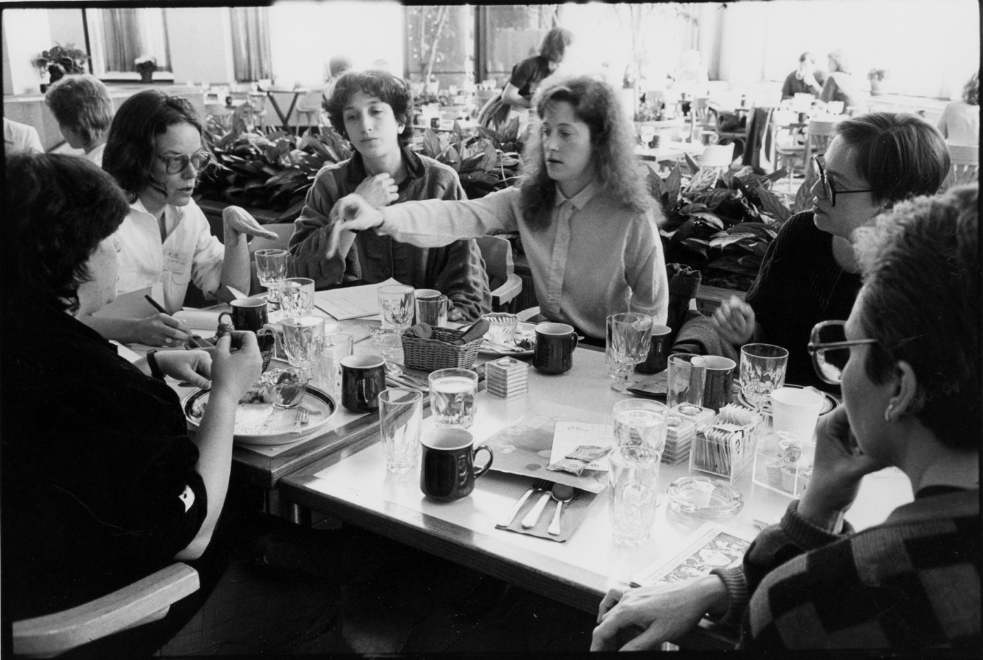
1985, (left to right, Sherry Millner, Catherine Lord, Sally Stein, Connie Hatch, Martha Gever). Photograph by Judith Lermer Crawley.

The Women’s Caucus was composed of many factions: those who wanted representation, those who wanted group support, and some who simply wanted to participate, but all wanting more out of photography than where things stood. Over time the Caucus has navigated the commonality of women identified as feminists and women who were interested in "women's issues," which were often seen as less aggressive and from a more conservative position. Regardless of these internal differences, programing goals were diverse enough to include all. As the Caucus grew internally, there were shifts in the focus and agendas that determined how to function as a caucus and as a sub-group within a larger organization. Because there had been no provision made for internal groups within the SPE, new rules had to be invented, and those rules kept changing.

The Women’s Caucus made their initial premise that the general purpose would be to further the interests and concerns of women in SPE and to form a network of mutual support. There was considerable conflict surrounding the initial women's meetings, which raised the question of whether men should be excluded. It was observed, and agreed upon by many women, that when men attended meetings focusing on women’s issues, they tended to dominate the conversation. Some women expressed realistic concerns that discussing any work-related pay discrepancies, sexual harassment, interviews, contracts, or power politics in front of their current and/or potential employers—often men—might affect their jobs. Finally, it was decided after considerable debate that men (of goodwill) would be allowed to attend Women's Caucus meetings as non-voting observers.

A Social Issues SPE group had also emerged but then disbanded (1982-1983). Caucus development was viewed as an ongoing factional activity. Conference conflicts continued, and by 1983 it was still a failed attempt to set terms for WC support based on numbers. The matter was again raised at the 1983 national conference in Philadelphia with the Teaching Women: Toward a Non-Sexist Photo Education panel organized by Barbara Jo Revelle. The panel was very controversial. Many voices were raised during the discussion and question period. At the Women’s Caucus meeting which followed, participants shared many grievances, sad testimonies, and brutal personal stories. Yet evidence of discrimination remained anecdotal, resulting in the request to survey the status of women in photographic education. The survey was supported by the Board but did not receive funding. Revelle felt that the Caucus should go ahead and do the survey anyway, as she was interested in doing the work, feeling that statistics would be crucial evidence and not dismissed. The job survey study sent 951 copies to institutions of higher education. It would subsequently receive the go-ahead in late 1984 and was published as the Survey of Women and Persons of Color in Post-Secondary Photographic Education in Exposure vol. 26:2/3 1988 Fall. The delay was mostly due to the complexity of the project. When it came out, the survey informed readers of the gender, race, and other disparities in academic and professional opportunities. Particularly, women constituted almost half the population of graduate students in photography (48.3%) and persons of color almost one-tenth of the graduate student populations (9%). However, at the tenured and tenure-track level, women occupied approximately 19% of the positions, and persons of color, 4%. A male faculty member was almost twice as likely as a female faculty member to be assigned to a tenure-track position or granted tenure. This research was intended to call attention to the inequalities which the SPE should be correcting.
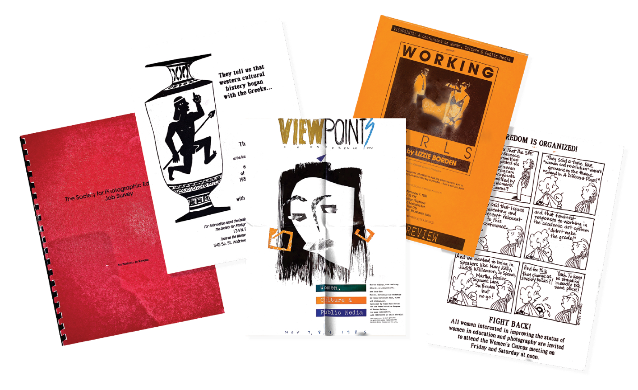
VIEWPOINTS Conference Schedule1986, 1987. Women’s Caucus advertising for programming, designer Debbie Bright, VIEWPOINTS 1986 movie poster; Working Girls, Lizzie Borden, Women’s Caucus meeting poster 1986, designer Virago.

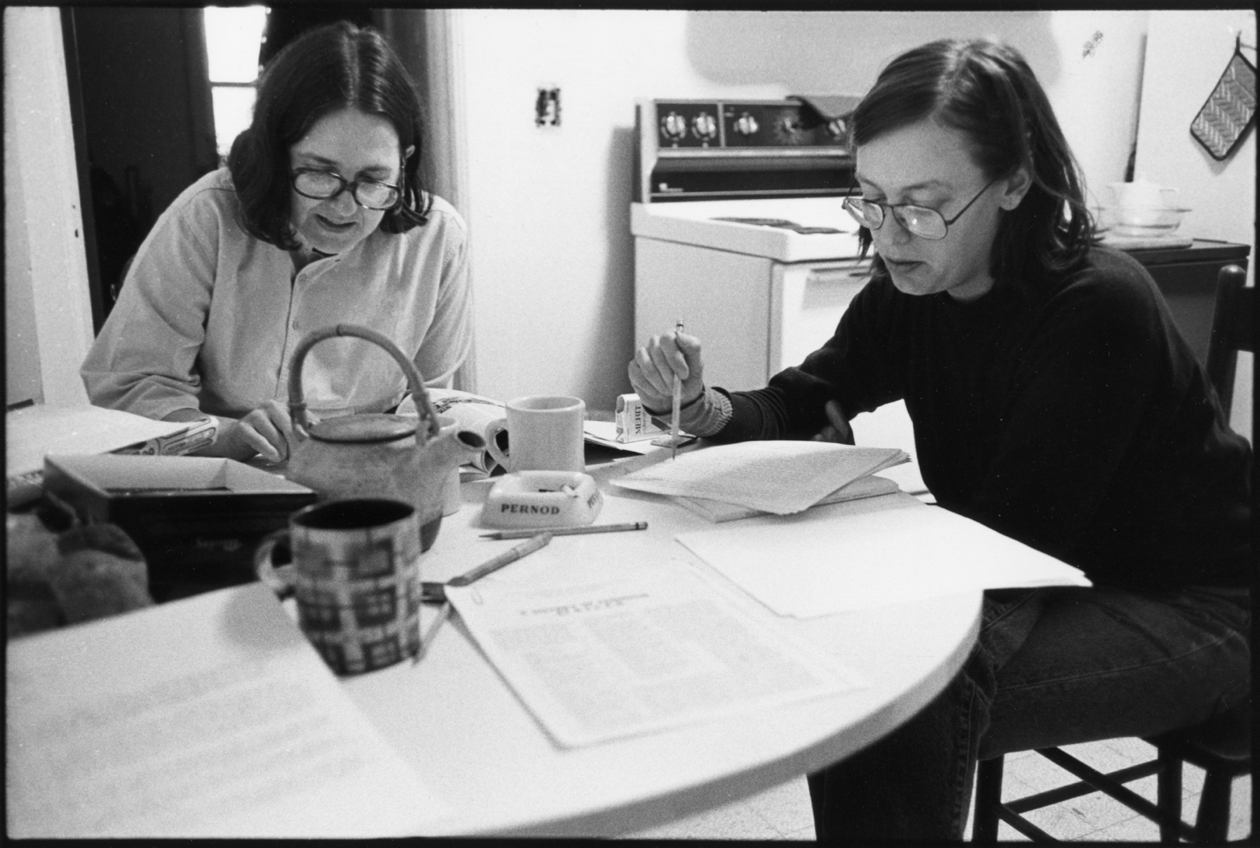
Editing Exposure, “What You Staring At” Aneta Sperber and Martha Gever, 1984. (Aneta Sperber left; Martha Gever, right). Photograph by Judith Lermer Crawley.

Still, women had not been invited to submit proposals to Exposure magazine, although the push for visibility perhaps led to the Summer 1981 issue of Exposure, titled Women in Photography, it was considered a token concession. The momentum continued to push for a women's guest-edited issue of the magazine. At the 1983 conference in Philadelphia, it was decided the Summer 1984 Exposure magazine was to be that issue. Edited by Martha Gever and Judith Crawley, along with Aneta Sperber and Rebecca Lewis, it included articles on women and the politics of photographic education. A report by Sally Stein about Britain's "Some Girls" poster series, an essay on Frida Kahlo and Tina Modotti, a polemic on the SPE and the Women's Caucus, plus feminists and the field at large, among others completed the publication.
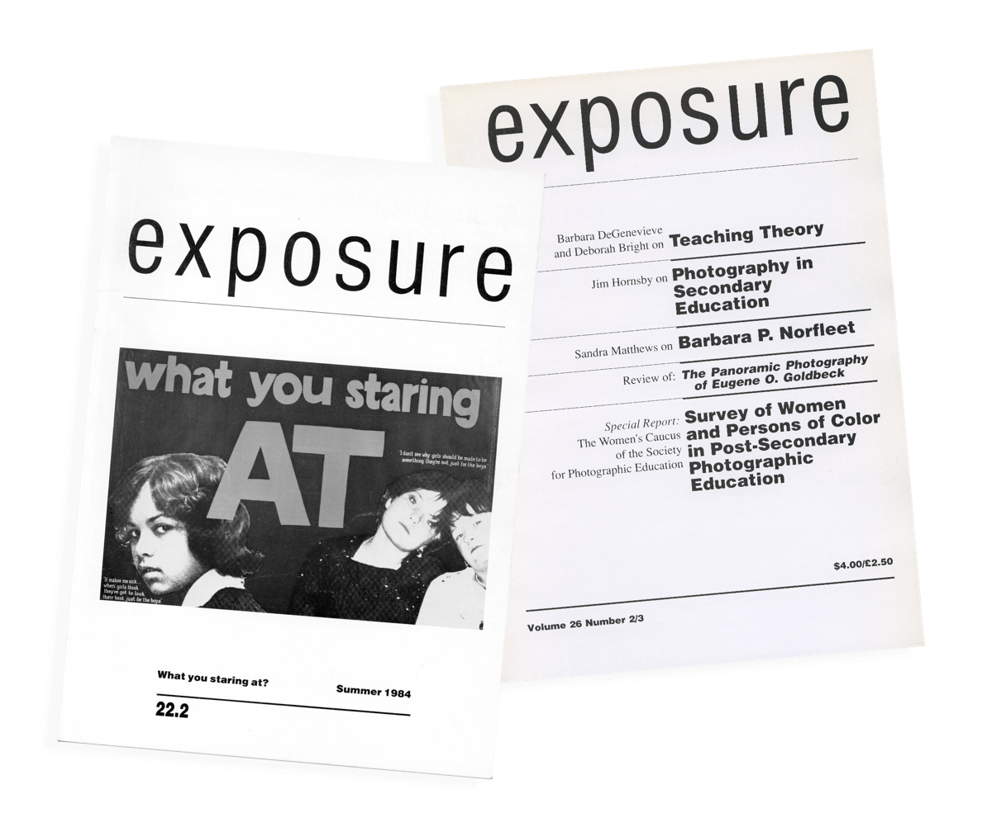
Exposure Magazine Volume 22.2 and 26 Number 2/3

Figuring out the details of how and who would be paid for their work on these issues and out of which funds, even though those procedures had not yet been established, was problematic. Neither the editors nor the contributors were paid for their efforts at first, despite the federal funding SPE received specifically for that purpose. Furthermore, payments to editors and contributors in the future remained unclear. This funding discrepancy also spurred conversations concerning unsupported, unfunded personal expenses incurred for expenses related to conference work, such as phone calls, postage, and travel. The Women's Caucus had calculated that 40% of SPE members were women, consequently, the Caucus felt fairly justified in requesting 25% of the selection of featured speakers, space for programming, and to chance nominate an active member as a prospective candidate for the Board.

From the Women's Caucus perspective, the 1984 Riverside conference is documented as a disaster, as it failed to include any women's programming. There were no female featured speakers and few women in the program as a whole. Each of the three nights, the keynote speakers were men, leading the Women's Caucus to presume that the following year, each evening speaker could be a woman. At this conference, the Women's Caucus came together again (with Sally Stein listed as liaison/chair to the Women's Caucus) on an ad hoc basis in response to a note posted by women attending the conference at 11:30 pm on the last night. The Woman's Caucus demands were reiterated: a survey concerning the status of women involved in Photographic Education, a full day's programming and input on the choice of one featured speaker, plus to have the Women's Caucus on the schedule for 1985 at 11 am not 11:30 pm. The Caucus would then meet every year, continuing to discuss and influence the role of women in the SPE organization.

The board had requested a formal statement of purpose with the caucus application prior to the 1985 Minneapolis conference. It was submitted as follows:
The Women's Caucus is a body of women committed to the advancement of women in the profession of photography and photographic education and the advancement of women's issues in the exhibition, discussion, and teaching of photography. Men's auxiliaries to the Women's Caucus are permissible and encouraged.

By conference time the approval was still delayed. The conference did include women, but funding became convoluted. This was the fifth annual national SPE conference in which the Women's Caucus figured as a significant intellectual, artistic, and political force. Nevertheless, discrepancies occurred in counting members, participants, and speakers, and who was eligible for payments. The Women's Caucus attested that 40%of SPE members were Women’s Caucus members that needed to receive up to 50% funding support as well as be part of the conference planning committee process. One of the panels openly invited discussion: What did they want? What do they want? What will they want? The Women's Caucus, the SPE, and the Declension of Desire. The moderator Sally Stein and the participants were Catherine Lord, Judith Crawley (representing the Women's Caucus), Peter Bunnell, and Martha Strawn (representing the Board of directors of SPE). Their goal was the furthering of a provocative view and encouraged conversation to promote change.

Because they were not recognized officially as a caucus, it became complicated and awkward during the Minneapolis Women's Caucus meeting. This difficulty led the WC to vote to exclude men from the meetings. Men were asked to leave. There was no bylaw concerning caucuses yet, which made it difficult to enforce rules or even have them. A concern was raised that a "Women Only" policy would be discriminatory. When one of the men complained, on the grounds of reverse discrimination (as SPE receives National Endowment funding, discrimination was barred), the Women's Caucus was asked to end their meeting. Group members describe the incident as seeing the walls being taken down around them and the chairs removed from under them. This led the WC to reconvene in the hallway. The women were certain that being asked to leave was against the rules required for the organization to receive National Endowment for the Arts (NEA) funding. Catherine Lord called the NEA contact (Paul Carlson) the following day and was advised that not allowing men to attend was not discrimination because groups organizing meetings were a private affair and those groups could include or exclude as they chose. Letters were written to the SPE Board demanding an apology for being thrown out. The Board decided later it was acceptable for the women to meet on SPE time, and it would not be discriminatory to exclude men, as men were allowed to attend the WC conference programing. The original complaint was later withdrawn once this was understood. Following that, the decision that caucus meetings were "Women Only" stayed in place for many years.

The Woman’s Caucus gained the approval of the Board's Executive Committee and the full Board on June 15th, 1985, and became official. With this, it was conveyed that the WC would receive no funding for its ongoing expenses from the SPE and a matter of record that no portion of the contributions received by the WC would revert to the SPE. As a caucus, they would be required to conduct and report projects of significance to the field.

Prior to becoming an official caucus, the group had by secret ballot preselected their representatives. Connie Hatch was selected as the liaison between the group and the Board; however, any of the five (Linda Brooks, Nancy Hamel, Connie Hatch, Catherine Lord, and Aneta Sperber) could equally choose to communicate with the Board at any time. The format of the group was to use a non-hierarchical relationship (continuing the circular, holistic mandate) with each of the five having an equal voice and power. It was agreed that any of the group could attend the board meetings.

Women's Caucus submitted seven panel proposals for the 1986 Baltimore Conference; all but one was rejected on the grounds that the proposals did not address photography or photographic education. The theme of the conference was promoted as Stand in a Different Place, which the Women's Caucus group firmly argued was included in all their proposals, and it seemed incongruous to have all but one declined. The one proposal that oddly was accepted included men. It was at that same conference the introductory opening included projected close-up images of various body parts combined with a small dance troupe performing a modest disrobing act while twirling sheets. Once again, the women walked out. The content of the presentation was deemed to have been so sexist and offensive that later the Board would vote, in an unprecedented move, to apologize, in print, to the Women's Caucus and to the entire SPE membership for the offensive and unprofessional presentation.
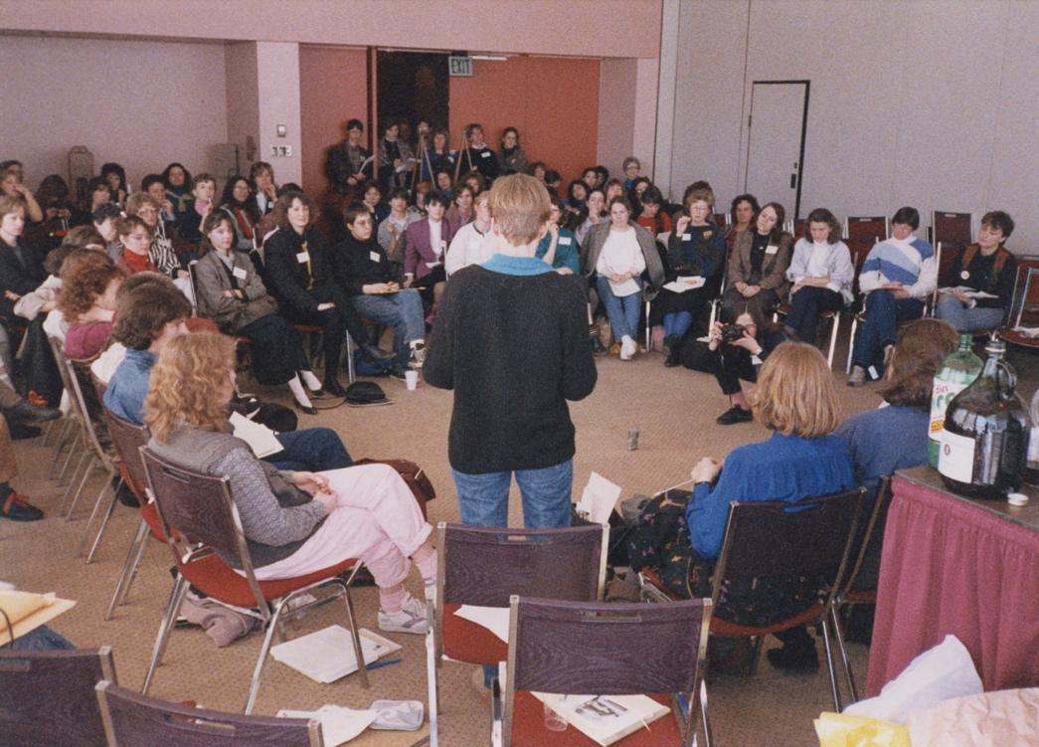
Baltimore Women’s Caucus Group, 1986. (Linda Brooks to left of speaker, Diane Neumaier to right, both facing away). photograph by Sally Stein.

The accepted panelists and proposal for the Baltimore Conference in 1986, Photos for Hire, included Jan Zita Grover, Deborah Bright, Christopher Phillips, Simon Watney, and Allan Sekula, all of whom had previously decided to yield their time to the WC. Two from the original Simone Watney and Chris Phillips, as “Adriana Angel” and “Fiona McIntosh,” declined proposal list, graciously consented to be smuggled into the proceedings of this national organization. The two presented a slide/tape version of their forthcoming (Writers and Readers) book, The Tiger's Milk. At this same conference questionnaires were circulated about improving programming. Half of the conference attendees signed a petition supporting the request for allocating funds for women's programing. Many women in groups stayed up until all hours of the morning spelling out precisely what they wanted. The Women's Caucus held a midnight meeting with the Board— with the WC threatening to organize a boycott should funding not be guaranteed. They convinced the Board they could do better programming. The following year, the members of the Women's Caucus received an apology from the Board for not having a properly functioning committee in place to act as a means to a court of appeal for the 1986 conference and for the treatment of their proposals. The events in Baltimore served as a significant influence in allowing the WC leverage to secure a 20% commitment of programing budget funds from SPE for the upcoming year and that year only (San Diego-1987).
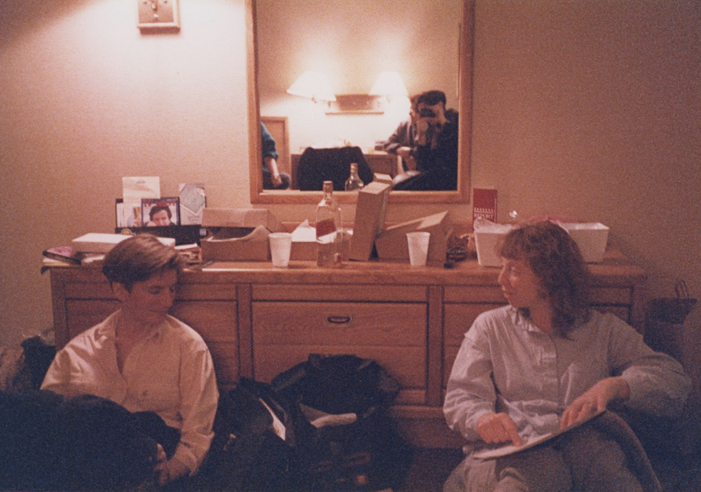
Baltimore Women’s Caucus, 1986. (left to right Debbie Bright and Linda Brooks). photograph by Sally Stein.

As the years marched on, so did the success of the WC, which is attributed to the strong personalities of many of the women involved and who also were resilient contributors to the underrepresented and the photographic field at large beyond the scope of SPE. The WC group continued to engage in diversified topics, such as older women and photography, lesbian representations, and work by women of other cultures. Their fundraising sponsored speakers, brought in people from overseas, supported their newsletter, and created exhibitions. WC members participated and promoted activities that supported their vision, such as the November 1986 free conference Viewpoints: A Conference on Women, Culture and Public Media at Hunter College. The conference was sponsored by Women Make Movies and the Women’s Studies of Hunter College. Linn Underhill curated the exhibit, which was a part of the conference, and many WC members participated.
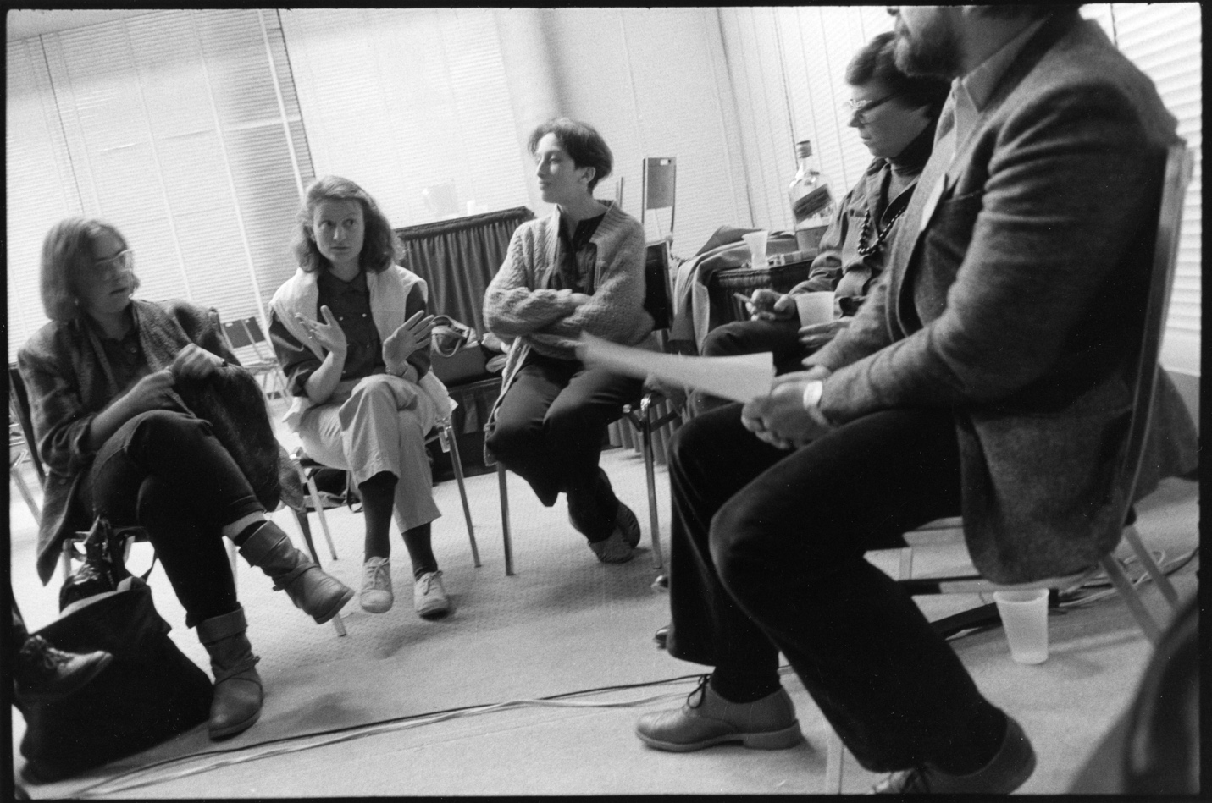
Caucus meets the Board 1986, (left to right, Diane Neumaier, Becky Lewis, Sally Stein), photograph by Judith Lermer Crawley

Following the selection and exclusion difficulties from the 1986 Baltimore conference, the bylaws were adjusted to recognize caucuses and to provide them with money, time, and space at the conferences. This still didn't assure easy integration. Even though the WC were told ahead of time that they would not get preferential treatment, the women expected inclusion in the programing and did not consider that preferential treatment. Progress is not without casualties. Caucus representatives Sally Stein and Catherine Lord met with conflict when they expressed concern that the final nominees for the 1987 featured speakers included only whites from North America and Europe. Both were removed from voting on the SPE Conference Committee, causing them to choose to resign from the committee.

The WC worked as a structure to gain momentum and to persuade SPE as an organization to adapt itself, structurally, to a variety of different agendas. When the 1987 conference took place, it brought a full day of programming and the first year of WC funding from the SPE. The total of 20% came to $3000, and the Women's Caucus raised $6000 more. Martha Rosler was the first woman Featured Keynote Speaker to receive funding. Her presentation was The Strange Case of Baby S/M: Representation and Woman’s Body. There was also a panel discussion reflecting social responsibility, visibility, and the conflicting roles of women's experiences. The Women's Eye: A Reconsideration was standing room only, with Gay Block from Los Angeles, Judith Crawley of Montreal, and Judy Dater of New Mexico, plus two curators, Anne Tucker and Ute Eskildsen. Tucker led the discussion, questioning, "What is this invisible screen that keeps out women's work?"

Along the way, there have been some humorous yet poignant events too; The Women's Caucus in 1987 proclaimed a new award: "The Severed Head Award." They connected their under-representation to “the over-representation of the aesthetic aspects of Joel-Peter Witkin's work, . . . and the gross misrepresentation of the actual content and implications . . . [of his work] which is misogynistic in the extreme.” They subverted the Imagemaker Joel Peter Witken’s presentation by creating flyers and circulating them announcing the Program Committee of the Sin Fronteras Conference as the winner of the First Annual Severed Head Award. This drew attention and helped publicize and create more support for the programming representation needs of the WC group. Their efforts inspired other groups to emerge as they instigated the system for inclusion, logistics, funding, and recognition. In the 1987 conference brochure, the Black Caucus in its early stages had a time set aside to meet, and there was discussion of a student caucus.
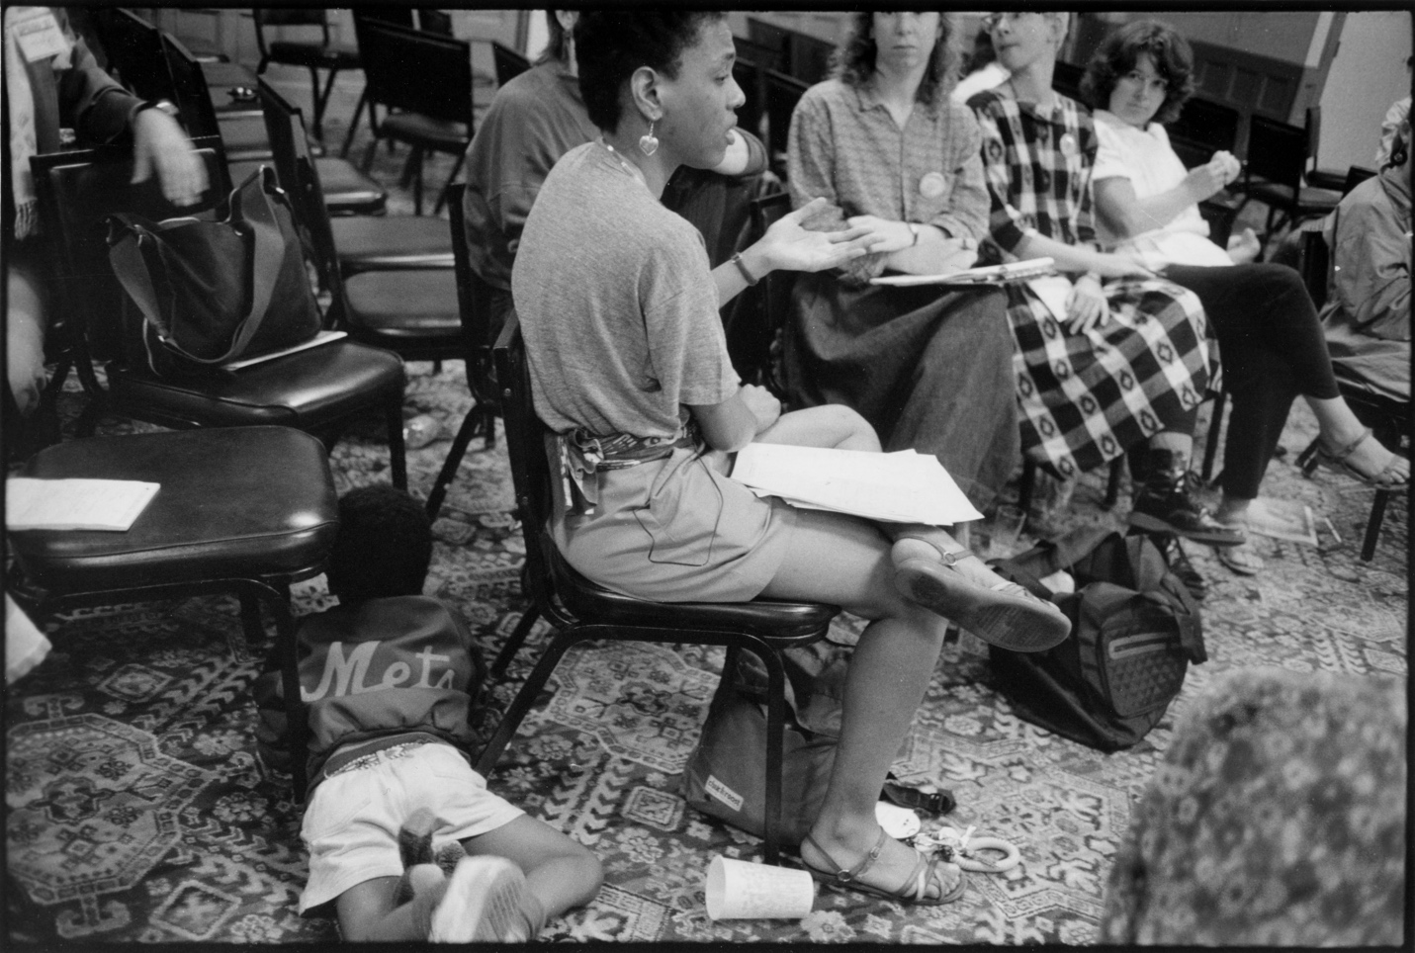
San Diego, 1987. photograph by Judith Lermer Crawley.

1988 Houston brought a SPE conference that was engaging and integrated, and the WC sponsored programming and received support funding again. An idea that surfaced this year was to count members in each caucus by having them check the box when paying for membership. This practice continues to be in place today. The conference programming committee was officially taken on as a Board responsibility in this same year when Deborah Bright, an elected SPE Board member, attended, and a block of funds was set aside for caucuses. The WC recognized the significance and importance of prioritizing keeping women representatives and advocates on the board. Regional conferences were starting to become more prevalent, especially in the Midwest and Northeast areas. Spring of 1988, the Northeast Women's Caucus, a regional affiliate of the national group, sponsored a weekend symposium, The Other/Voices: Issues of Representation and Criticism in Photography, at the New School for Social Research in New York City. These regional conferences helped strengthen participation within the Caucus and also added a more personal opportunity for smaller groups to engage within the larger SPE.
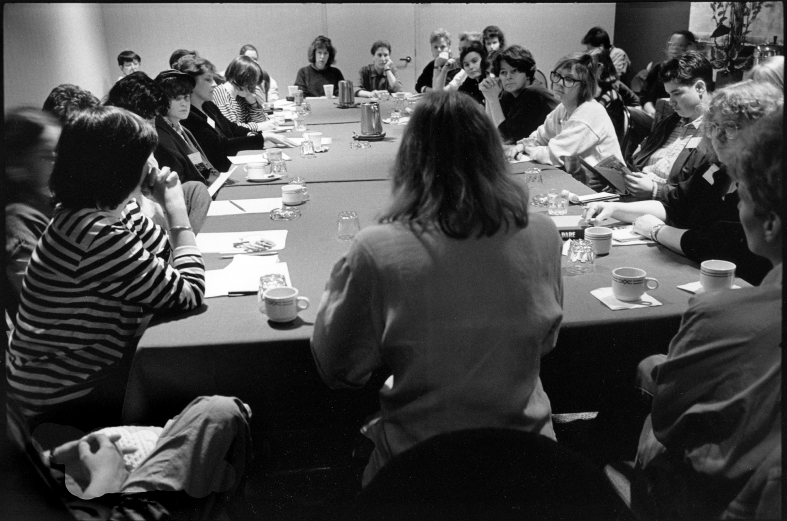
1988 photograph by Judith Lermer Crawley

Adversity and negativity behind the scene continued, ranging from comments of “strident feminist” to the outright rejections of support from those who controlled decisions. Early in 1989, photographic historian Bill Jay issued a manifesto that was published first in Shots magazine in the January-February issue, and reprinted in Photo Metro in April 1989. Grant Kester describes this manifesto as the observer’s perspective of the SPE’s internal developments and changes:

[Of sorts] attacking the Women's Caucus of the Society for Photographic Education as a 'nasty little pimple on the face of photographic education,’ run by 'frothing at the mouth feminist leftists' who were using 'scurrilous feminist propaganda' to 'distort' and 'subvert' the field.’

This manifesto caused many rebuttal articles and heated discussions which drew the attention to the fact that the issues acknowledged were not exclusive to the WC debate. The following is from the 1989 Women’s Newsletter:

Bill Jay's article touched a sensitive spot. It dared bring out in the open what members and non-members, women and men alike, have been discussing behind the scenes for years.

Many attacked it for its form and not its content which could seem a simple political tactic intended not to address the many asserted observations by Jay. If Jay's accusations sounded harsh and unfair at times—nobody liked to be called a "fascist" or be equated to a "nasty little pimple"—the issues he brings outreach far beyond the Jay vs. Women's Caucus debate. But if the letter, in its inflammatory style, addressed important questions, it failed to point out the power struggle within SPE and academia in general and the fact that the ‘pseudo Marxists feminists’ are part of a larger group which includes men.

Since Jay called for a boycott of the Rochester National conference, there was some concern that this publicity would decrease attendance at conferences, but interest and attendance continued to thrive. WC projects also continued to move forward. One of the projects related to Women's Service to the Field was an Artist and Representation Survey of Women Photographer's Representation in Galleries and Museums, which had board support but no funding. Instead of this project, the group turned their attention to FIX IT (Feminists in Exile), an exhibition sponsored by the Women's Caucus with Nancy Gonchar as contact person. The exhibit functioned to expose the underrepresentation of women and minorities in exhibition spaces, collections, publications, photographic education and practice. The works addressed issues such as hiring practices, employment conditions, and the composition of art faculties, in themes of gender, race, sexual orientation, and class. The exhibition was designed to uncover exclusionary practices in the photographic community, and to challenge and even change the powers that be in the SPE and the larger photo world, on the understanding that we are all makers of the culture. The intention of FIX IT was to state the record of The Other. It was held at the 1989 SPE National Conference in Rochester. The FIX IT exhibition had the first stop of its national tour at the Women's Center at the University of California, Santa Cruz. After the tour, the exhibit was donated to the Visual Studies Workshop in Rochester. A second phase was organized: FIX IT II in Chicago which was an open exhibit of visual and textual information concerned with women in photographic education. Anything which could be faxed was to be accepted: personal stories, statistics, and visual artifacts were pertinent.
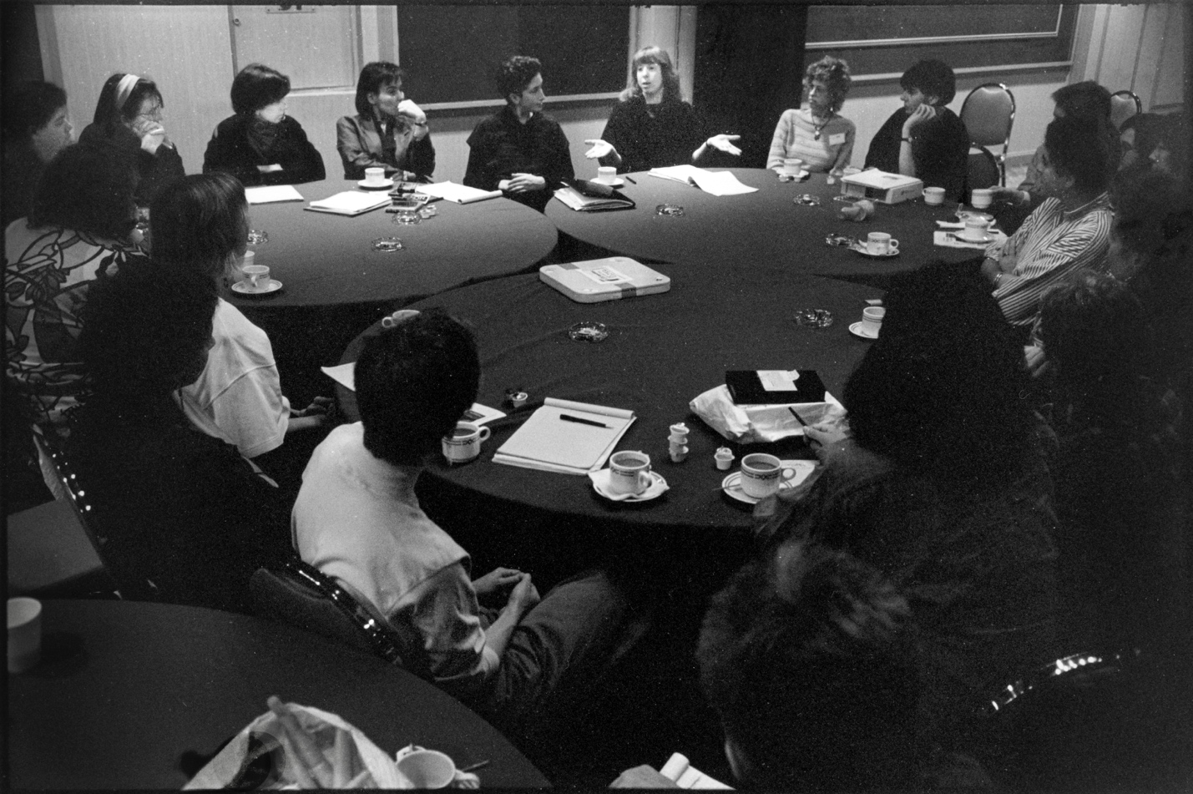
1989, (Linda Brooks promoting FIX IT), photograph by Judith Lermer Crawley.
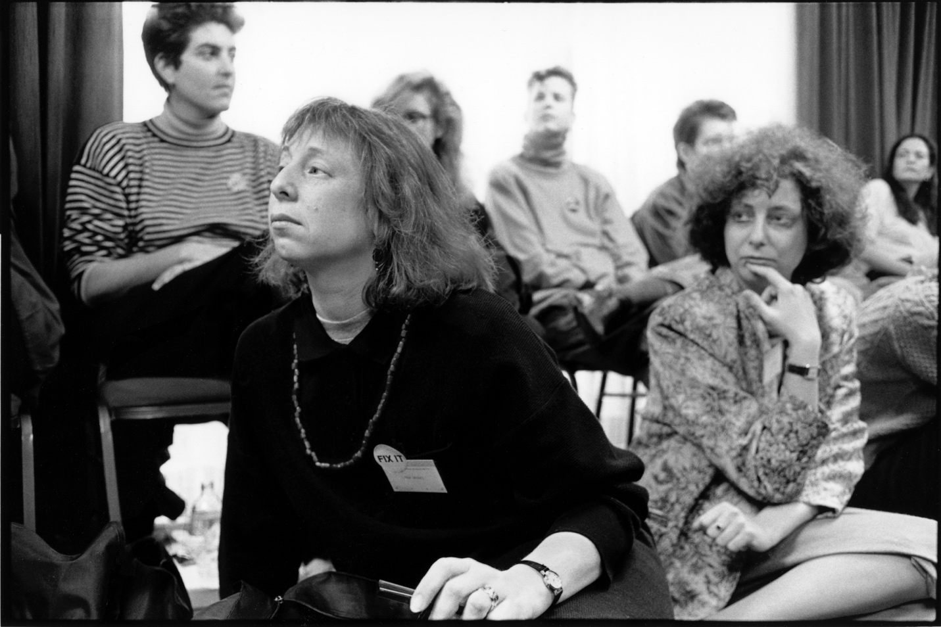
1989, (Linda Brooks promoting FIX IT), photograph by Judith Lermer Crawley.
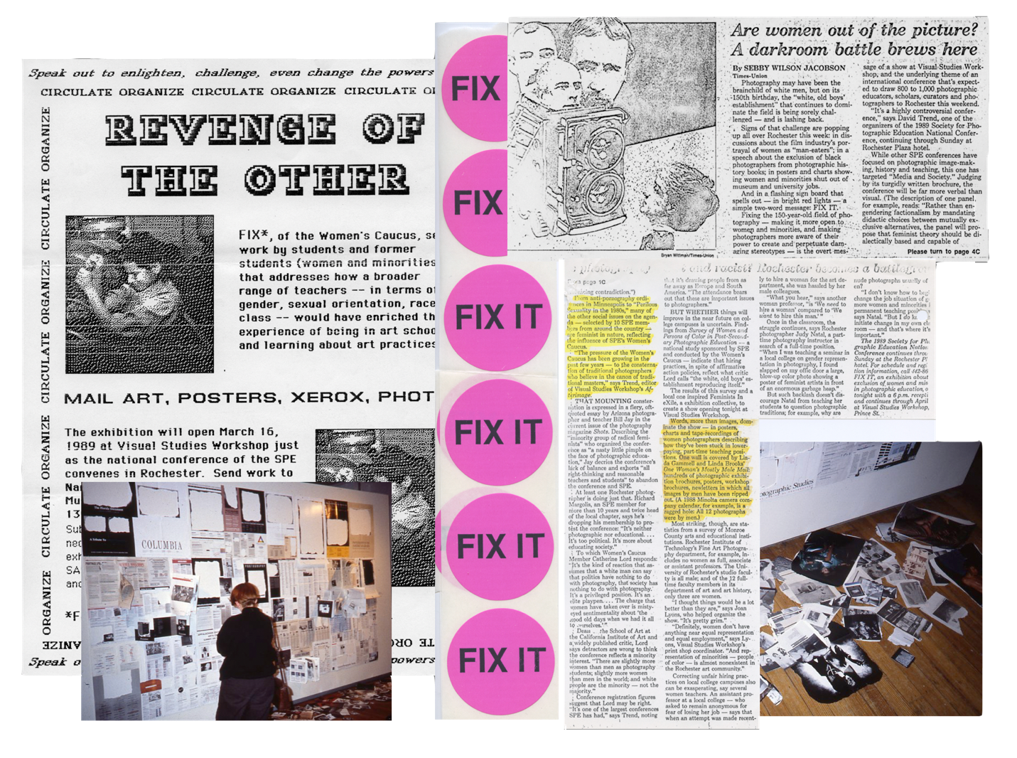
FIX IT artifacts, March 1989, collage data assembled by Linda Brooks.

The first ten years were formative, and to arrive at a consensus from a multitude of perspectives was challenging. All of this played into the outcome of deciding the allocation of funds for conferences, participating in the editorial direction of Exposure and creating a generation of studies concerning the hiring field. In 1989, Linda Brooks became the liaison for the WC and brought her knowledge and guidance to the group. By 1989 any and all caucuses were eligible for funds, and as more caucuses emerged, such as the Multi-Cultural Caucus (MC) in 1990, the rotations of speakers selection choice would rotate as well. It was considered essential to have a liaison between the caucuses and for the caucuses to work together supportively. Film and video continued to appear most years, and early curators were Martha Gever and B. Ruby Rich, followed by Angela Kelly. In 1995 Lynn Estomin took on the challenge of curating film and video work for the SPE Women’s Film Festival. The SPE Media Festival is now juried by representatives of the WC, MC, and LGBTQ Caucuses. Internationally known artists, writers and historians were invited by the WC to present. A partial list includes: Abigail Solomon-Godeau, DeeDee Halleck, Suzanne Lacy, Constance Penley, Margaret Randall, Jolene Rickard, B. Ruby Rich, Rebecca Solnit, and Judith Williamson.
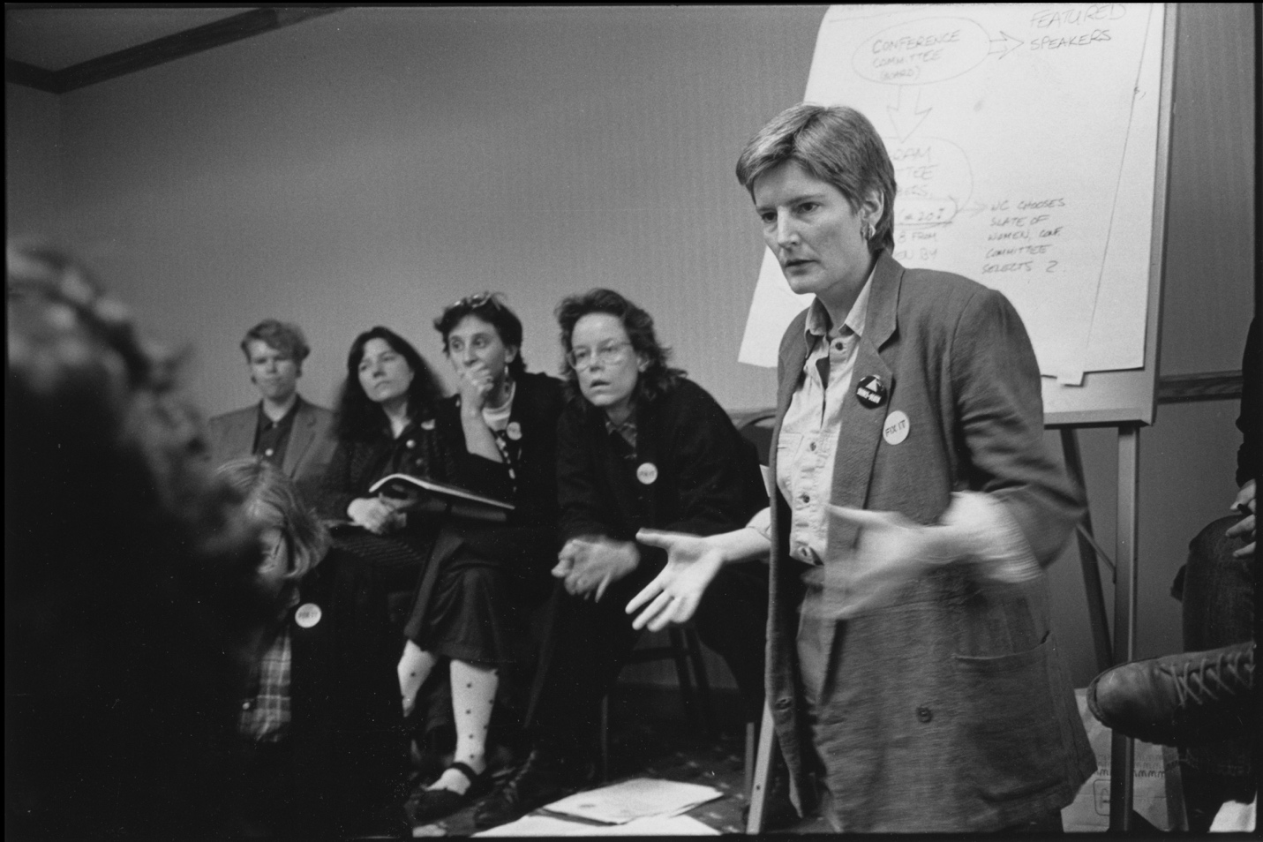
1989, (right to left, Deborah Bright, Catherine Lord, Sally Stein), photograph by Judith Lermer Crawley.

Collaborating within caucuses and sharing equality was an important focus. In the year 2000, the Multi-Cultural Caucus missed their turn in the rotation and the WC offered theirs. Contact and communication between the groups was still essential, and as more caucuses may join, the rotation of speakers and seats on the national selection will continue to rotate as well.

Liz Allen brought her photographic curatorial expertise in to the Women's Caucus in 2002 as chairperson/liaison. Meetings continued to feature a conversation among attendees about which issues were important to them and what speakers they'd like to hear. The opinions voiced in these meetings continued to inform decisions about guest speakers and future panel representation. During meetings, the arrangement of seating maintained a circular format. By 2004 it was decided two WC meetings would be held at each conference, one of which would include invited men. Women’s artist mentorships were introduced, and the presence of women's professional exhibitions increased and became a focus for promotion of the group. Previously, exhibition work was accepted as an open call and Allen added the component of inviting significant jurors to select the work to be exhibited. While Allen was serving as Chair, two shows were curated by Joyce Neimanas and Patrick Nagatani. One exhibit was hosted by Arts at CIIS at the Minna Street Center in San Francisco, and one at Trois Gallery at the Savannah College of Art and Design (SCAD) in Atlanta, 2011 which then traveled to Northlight Gallery in Arizona.

In 2013, the first Combined Caucus exhibition was announced. Included were the Multi-Cultural Caucus and the newly formed LGBTQ Caucus. The exhibition was held at the Harrington College of Design in Chicago as part of the 50th anniversary conference of the SPE. The following year, 2014, at the Baltimore conference, Leslie King-Hammond and Catherine Lord juried the second collaborative effort of a combined caucus exhibition. Catherine Lord was the sponsored speaker. The exhibition Collaborative Exchanges: Photography in Dialogue was published as an on-line exhibition with VASA, along with Catherine’s presentation on the oral history of the WC, Tender Buttons.

Looking back at the early days, Catherine Lord’s statement in the 1985 SPE newsletter states a brilliantly insightful argument representing the voice of all the women and under-represented people in the Society for Photographic Education:
I want SPE to take prompt and effective steps to address that large sector of its constituency whose needs and issues have been given merely token respect and belated action. Women in photography and the arts still pay, and pay daily, the price of sex­ism: in scholarships, grants, jobs, salaries, exhibitions, publications. We pay by working just as hard to stand in exactly the same place. SPE has an obligation to lobby to redress discrimination. It also has an obligation to put women's issues onto its agenda: the feminization of poverty, for example, the politics of representation, the economy of power, the assumption of universal heterosexuality. For the organization to continue its attitude of benign neglect towards women amounts to the embezzlement of dues. It won't be easy. But I'm not afraid of bureaucracies, debate, or decisions. I want women's issues represented in SPE, as a matter of course not as an occasional exception, because I believe that it will allow the organization to admit the issues of races other than white, of nationalities other than American, of institutions other than academy. It will, in the end, expand horizons.

The SPE organization adapted and evolved to where it is today with robust and diverse programming. The Women's Caucus is deeply integrated into the fabric of the SPE. They host programming that is more contemporary, diversified, open-ended, engaging, and supportive. Is it perfect? No. Things have changed a lot, and things haven't changed that much. Is there work to be done? YES! And all in the SPE community have that in mind as their focus in photography continues along with their passion for inclusion. New additions to the special interest groups continue. In addition to the Women’s Caucus, Multicultural Caucus, and the LGBTQ Caucus, there are two new caucuses, the Contingent Faculty Caucus and the High School Educator's Caucus, and a student caucus is just starting to re-emerge. The organization has started to relax, and the selection of speakers changed from a board decision to a caucus decision. Katharine Kreisher and M. Laine Wyatt, co-chairs from 2013-2018, witnessed the evolution of women's needs, including a shift to a more electronic media. The group meetings would start out arranged in a circular format, sometimes double or triple rows deep depending on the meeting space and the meetings’ format started with minutes and group conversation. A new component of internal breakout groups was added to increase productivity in the time allocation. Some new activities were added to the previous commitments: the conference programming, exhibition research, funds, representatives, film festival, and archives to now include help in job search, internet group-promotion, and staying competitive. Shared mentorships have continued. Now men may attend as invited allies.

Today the Women's Caucus continues to meet every year nationally and regionally. It remains an open forum for all women interested in participating, as it continuously evolves and struggles to maintain its somewhat pluralist feminist perspective. That perspective is informed by not only the history of the SPE but also the history of the Women’s Caucus itself. Witness to evidence of the growth, women’s participation and benefits to the SPE organization is that many WC members have been elected by the general membership to leadership positions on the SPE Board over the 40-year history of the Women’s Caucus. That includes Barbara Jo Revelle, Angela Kelly, Margaret Stratton, Deborah Bright, Sant Khalsa, and Liz Allen among others who identified as members of the WC at some point. Over the years additional Board members and Directors including Deborah Willis, Wendel White, and Judith Thorpe have been very supportive allies of the WC.
Two members of the Women’s Caucus shared their thoughts about their experiences. Linda Brooks commented:
To be certain, the continued vitality of the Women’s Caucus over the last eighteen years must be attributed to the stability of the long-term commitment and leadership of Liz Allen, the co-leadership of Katharine Kreisher and M.Laine Wyatt, and most recently the co-leadership of Sarah Ann Austin-Bagley and Patricia Lois Nuss Bambace. The mentorship of past leaders has certainly played a role in the consistency and evolving direction of the caucus. Not only within the caucus, but across the inclusive entities of various constituencies and caucuses.

Sant Khalsa wrote:
The evolution (change and growth) that came to SPE, the field of photography and academia from the efforts of the WC was critically important and meaningful. I was glad to serve on the National Board from 1989-93 and the National Conference Committee as well as Chair the 1990 National Conference in Santa Fe and assure that programming was inclusive and equitable during those years.

It took time, the evolutionary progression of events, and the redefining of criteria to accomplish the goals of the Women's Caucus since its accepted existence in the days of snail-mail and typewriters. This was a more conservative time; the WC had to fight for everything. Feelings were hurt, egos were bruised, things were said, lots was written, and some wasn't pretty. The Woman's Caucus was formative; it shaped and affected peoples sense of themselves and their position within the organization and the field. The Women's Caucus continues to serve as a role model and a support network for women involved in the field as students, teachers, artists, scholars, and critics. Notably by insisting on separatism and integration at the same time, the Women’s Caucus ensures against its own marginalization and continues to define feminism as an active, changing, and ongoing process.

Thank you for all of your efforts contributing to this history including running meetings, taking photographs, organizing WC programs at SPE National and Regional meetings, participating on panels, presenting projects as Imagemakers, and presenting by invitation as featured speakers and honored educators: Liz Allen, Sarah Ann Austin-Bagley, Patricia Lois Nuss Bambace, Eileen Berger, JEB (Joan E. Biken) Deborah Bright, Kaucyila Brooke, Linda Brooks, Esther Bubley, Cathy Cade, Ellen Carey, Judith Crawley, Joyce Culver, Dorit Cypis, Lynn Davis, Barbara DeGenevieve, Rita Dibert, Leslie Ernst, Lynn Estomin, Ann Fessler, Nancy Floyd, Ruthe Foote, Linda Gammell, Judy Gelles, Martha Gever, Nancy Gonchar, Arlene Gottfried, Jan Zita Grover, Jane Grundy, Danielle Gustafson, Nancy Hamel, Wanda Hammerbeck, Connie Hatch, Barbara Hershey, Dorothy Imagire, Barbara Jaffe, Louise Jefferson, Karen Johnson, Barbara Kasten, Angela Kelly, Sant Khalsa, Rosalind Kimball Moulton, Yvonne Klocek, Katharine Kreisher, Suzanne Lacy, Rebecca Lewis, Linda Lindroth, Catherine Lord, Fern Logan, Mary Ann Lynch, Joan Lyons, Martha Madigan, Susan Makov, Silvia Malagrino, Sandra Matthews, Bea Nettles, Diane Neumaier, Catherine Opie, Esther Parada, Susan Rankaitis, Gail Rebhan, Barbara Jo Revelle, B. Ruby Rich, Martha Rosler, Joanne Seador, Clarissa Sligh, Barbara Sonneborn, Sally Stein, Margaret Stratton, Martha Strawn, Joan Strommer, Aneta Sperber, Linn Underhill, JoAnn Verburg, Bonita Wahl, Carrie Mae Weems, Pat Ward Williams, Deborah Willis, Connie Wolf, M. Laine Wyatt, Cheryl Younger and Jeri Zbiral among many others.

Notes Finding Aid, Center for Creative Photography Archives.
Grant Kester, “Art, Activism, and Oppositionality: Essays from Afterimage.” ed. Kester, Grant, 1998.
Martha Gever, “WC Proposal to the Board.” Center for Creative Photography Archives, Feb. 1985.
Judith Crawley, “WC Meeting Notes.” 1985.
History.com Editors, “Equal Rights Amendment passed by Congress ” A&E Television Networks, February 9, 2010, September 20, 2020, https://www.history.com/this-day-in-history/equal-rights-amendment-passed-by-congress.
Catherine Lord, “Tender Buttons,” VASA Project - Online Workshops, Talks and Exhibitions in Photography,New Media, Sound Art and Visual Studies (Society for Photographic Education, March 7, 2014), http://www.vasa-project.com/gallery/spe/lord-essay.php.
“Women’s Caucus Newsletter,” April-May 1980.
Linda Brooks, et al. "Re Representation," Afterimage 13, nos. 1 & 2 (Summer 1985); 42.
Finding Aid, Center for Creative Photography Archives, 7.
“Riverside Meeting Agenda.” SPE WC Archives, 1984.
Exposure, V. 26, 2/3, Fall 1988, 46.
“Oral History of WC.” Ruckus WC Newsletter, Spring 1994.
Judith Crawley, “Meeting Notes.” SPE WC Archives, 1985.
“Internal Letters.” SPE WC Archives, September 11, 1985.
Martha Gever, “WC Proposal to the Board.” Center for Creative Photography Archives, February 1985.
“WC Meeting Notes.” SPE WC Archives, April 1984.
“Formal Caucus Application.” SPE WC Archives, March 1985.
“Introduction Comments.” SPE Program, Minneapolis, 1985, 1.
“Letter to the Board.” SPE WC Archives, February 1985.
“New Order/No Order.” SPE Program, Minneapolis, April 1985, 20-21.
“Internal Letters.” SPE WC Archives, March 29, 1985.
“Oral History of WC.” WC Spring Newsletter, 1994.
“WC Acceptance Letter.” SPE WC Archives, August 21, 1985.
“Internal WC Member Update.” SPE WC Archives, August 28, 1985.
“Oral History of the Woman’s Caucus.” Ruckus WC Newsletter, Spring, 1994.
“WC Newsletter Draft.” SPE WC Archives, April 18, 1986.
“WC Newsletter Draft.” SPE WC Archives, April 18, 1986.
“Report on Women’s Eye.” SPE WC Archives, March 30, 1987.
“WC Newsletter Draft.” SPE WC Archives, April 18, 1986.
“WC Internal.” SPE WC Archives, December 13, 1986.
Chicago Tribune. Sec. 7. April 24, 1987.
“Artifact Document.” SPE WC Archives, April 14, 1987.
“Oral History of WC.” Ruckus WC Newsletter, Spring 1994.
Bill Jay, “Fascism of the Left,” Shots, Jan/Feb. 1989, reprinted in Photo Metro, April 1989, 25.
Grant Kester, “The world he has lost; Dave Hickey's beauty treatment.” Variant 18, Autumn 2003.
Bill Jay, “Fascism of the Left,” Shots #22, Jan./Feb. 1989, reprinted in Photo Metro, April 1989, 25.
“The Other”, Call for Entry Fix It Poster, March 16, 1989
Women’s Caucus Newsletter. April-May, 1980.
“Meeting Minutes, Report to the Joint National and Regional Board Meeting.” SPE, WC, Newport, RI, March 25-26, 2004.
Catherine Lord, SPE Newsletter, November 1985. 3.
Lorraine Kenny, “Draft of Manuscript (intended for “Separation” Issue of Heresies),” SPE WC Archives. 1988. 13-14. Bibliography “Artifact Document.” SPE WC Archives. April 14, 1987. Brooks, Linda, et al. “Re Representation.” Afterimage 13, nos. 1 and 2. 42. Summer 1985. 42. Chicago Tribune. Sec. 7. April 24, 1987. Crawley, Judith. Women’s Conference (WC) Meeting Notes.” 1985. “Equal Rights Amendment Passed by Congress.” Ed. Histroy.com. A&E Television Networks, February 9, 2010. https.//www.history.com/this-day-in-history/equal-rights-amendment-passed-by-congress. Exposure, V. 26, 2/3, Fall 1988, 46. “Finding Aid.” Center for Creative Photography Archives. 7. “Formal Caucus Application.” SPE WC Archives. March 1985. Gever, Martha. “WC Proposal to the Board.” Center for Creative Photography Archives. February 1985. “Internal Letters.” SPE WC Archives, September 11, 1985. “Internal WC Member Update. SPE WC Archives. August 21, 1985. “Introduction Comments.” SPE Archives, Minneapolis, 1985. 1. Jay, Bill. “Fascism of the Left.” Shots. #22, Jan/Feb 1989. Reprinted in Photo Metro, April 1989. 25. Kester, Grant, ed. “Art, Activism, and Oppositionality: Essays from Afterimage.” 1998. Kester, Grant. “The World He Has Lost: David Hickey’s Beauty.” Variant 18. Autumn 2003. “Letter to the Board.” SPE WC Archives. February 1985. Lord, Catherine. SPE Newsletter. November 1985. 3. Lord, Catherine. “Tender Buttons.” VASA Project-Online Workshops, Talks, and Exhibitions in Photography, New Media, Sound Art, and Visual Studies. Society for Photographic Education, March 7, 2014. http://www.vasa-project.com/gallery/spe/lord-essay.php. Kenny, Lorraine. “Draft of Manuscript. Intended for Separation issue of Heresies.” SPE WC Archives. 1988. 13-14. “Meeting Minutes.” Report to the Joint National and Regional Board Meeting.” SPE WC Newton, Rhode Island. March 25-26, 2004. “New Order/No Order.” SPE Program, Minneapolis. April 1985. 20-21. “Oral History of the WC.” Ruckus WC Newsletter, Spring 1994. “The Other.” Call for Entry Fix It Poster. March 16, 1989. “Report on Woman’s Eye.” SPE WC Archives. March 30, 1987. “Riverside Meeting Agenda.” SPE WC Archives. 1984. “WC Acceptance Letter.” SPE WC Archives. August 21, 1985. “WC Internal.” SPE WC Archives. December 13, 1986. WC Meeting Notes. WC Archives. April 1984. WC Newsletter Draft. SPE WC Archives. April 1986.

